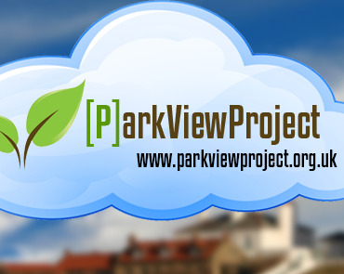

Volunteer Online Chum Mentor
(The role)

A volunteer Online Chum is an activity designed to support the mentoring of residents across North Tyneside who experience challenges because of the rapid acceleration in the use of digital services. Many of our beneficiary’s experience frustration and fear of using the internet, which has a potential impact on their independence. This takes many forms such as accessing government forms to managing council tax, housing benefit, banking or online shopping. Furthermore, Park View’s social goals are to give people the opportunity to socially connect offline. In other words, Online to Offline.

Our beneficiaries represent a cross section of the local community who because of age, disability or poverty, have not had the opportunity to engage positively with digital-based services. Many are young people who have experienced cyberbullying, older people subject to scams, those who have no access to PC’s, laptops or smart phones. The one thing they do have in common is, they have found themselves disenfranchised unable to manage day to-day activities that we all take for granted.

The volunteer Online Chum Mentor is a Befriending type role where a commonsense understanding of use of emails or accessing online services is all that is needed. However, the role requires someone who is a people person, interested in enabling and empowering individuals to take control over their digital footprint. You can find yourselves helping residents in the following ways: -

- For example, supporting someone navigating our Active Learning Program called Community Reporters, which provides an opportunity for our service users to practice creating an article/story or a project of their choice. This aims to increase social circles of support for some, but primarily covers all the basic points needed to transfer their learnt skills to managing their digital outputs.

- We also have three websites which are constantly in development, which is an area of interest our Online Chum Mentors may wish to contribute both design and content.

- Marketing our services

- Fund raising.

Our volunteer Online Chum Mentors are given training in working with Park View Project’s aims & objectives, ongoing support and an opportunity to create your own personal development portfolio.

Park View Project have several partner organizations locally who allow access to their IT suites as well as other services to widen interests of those participating. For example, Cullercoats Family History Centre and North Tyneside disability Forum.

All your involvement will take place either at Whitley Bay, Cullercoats or Shiremoor. You will not be expected to visit people’s homes, although this may be incorporated in a future development of the services.

This is a pilot project to gauge the derived benefits from our volunteers and how their role supports those on the digital periphery.

You can check out our Online Portal website at: Park View Project - Public Portal

Park View Project are keen to involve those who consider themselves to have a disability or have experienced those issues we have described. However, everyone is welcome to participate in this team-based training as we believe that diversity is at the core of our work.

