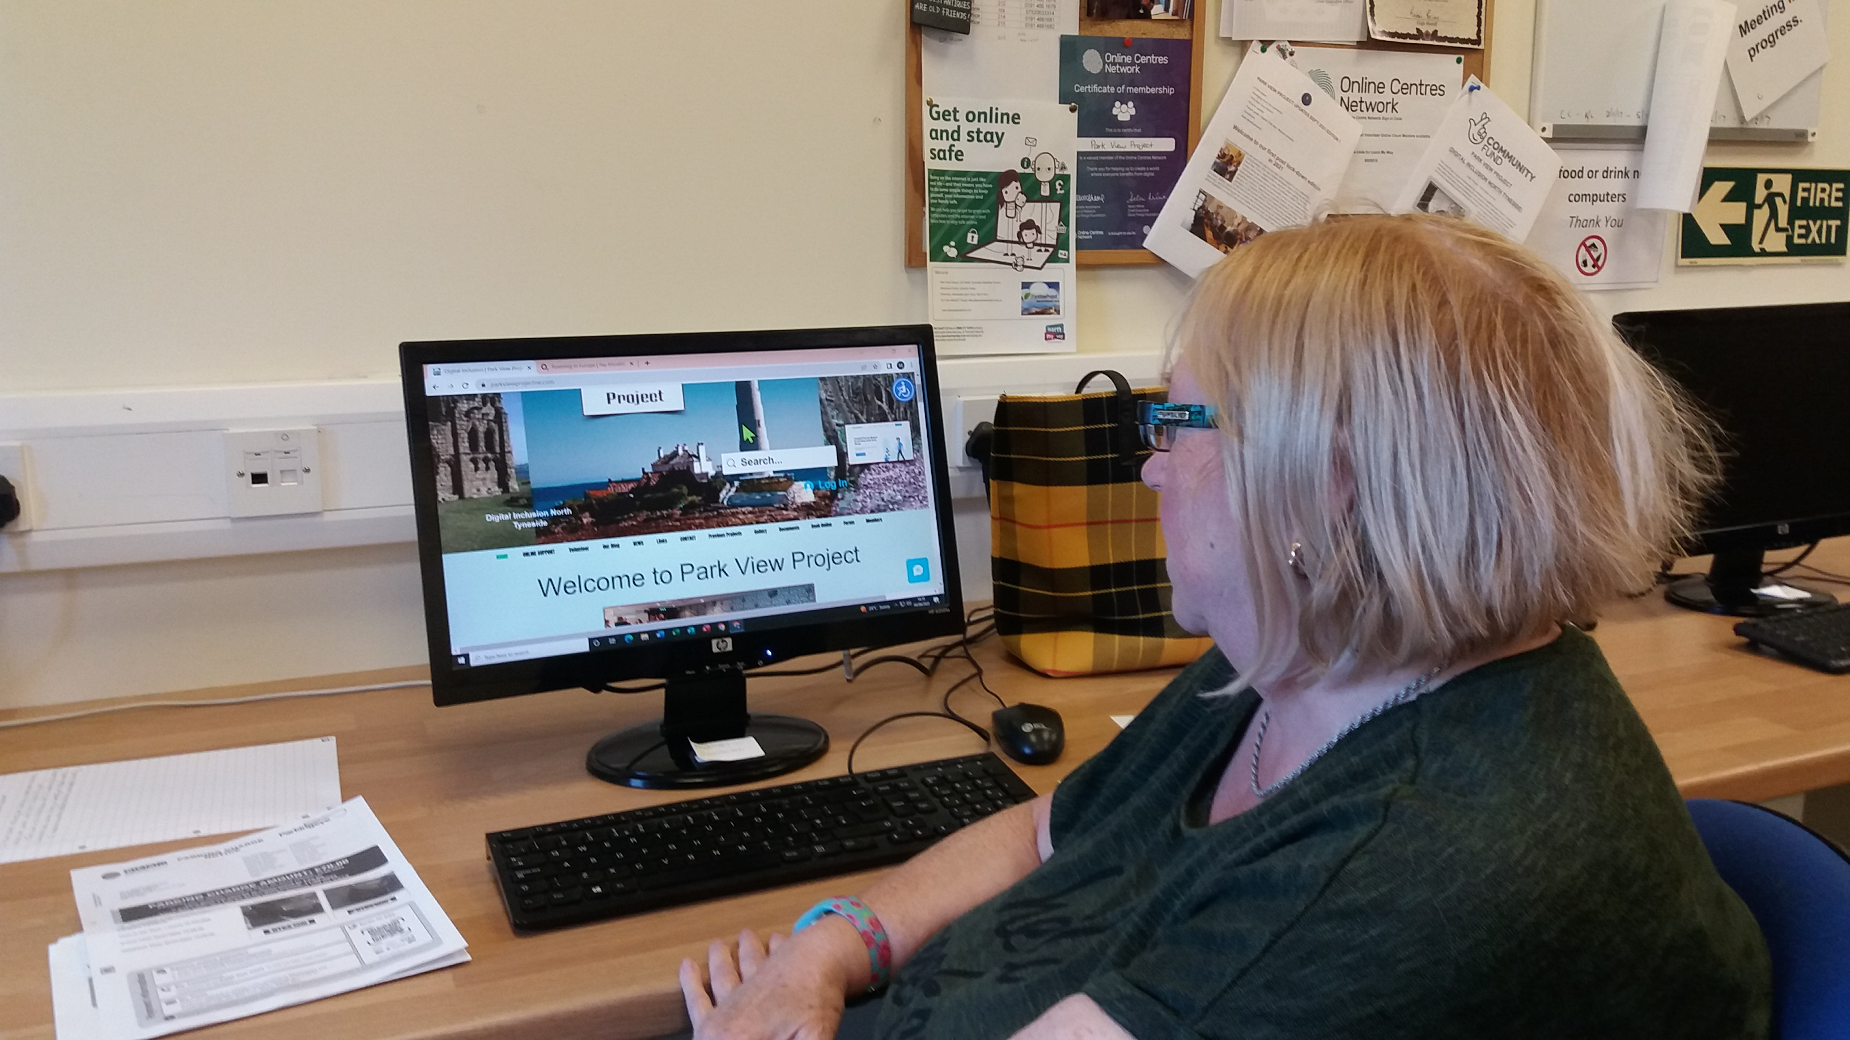
Park View Project (Digital Inclusion North Tyneside)
NTDF Centre, Earsdon Road, Shiremoor, Newcastle upon Tyne, NE27 0HJ
Charity number 1196503

Annual General Meeting 28th March 2025
Object[s]
The objects of the CIO are:
To promote social inclusion for the public benefit by preventing people from becoming socially excluded, relieving the needs of those people who are socially excluded and assisting them to integrate into society but not exclusively, by improving their digital skills and in such other ways as the trustees consider appropriate. For the purpose of this clause ‘socially excluded’ means being excluded from society, or part of society, as a result of being a member of a socially and economically deprived community.
Trustees:
Ann Craven
Helen Dawson
Sue Adams
Martin Lee
Simon Schofield
Vicki Peacock (Chair)
Bankers: Barclays Bank.
Aims of the organisation:
1. Enable residents of North Tyneside to manage day-to day household tasks using digital media and internet products. (All makes and models including managing a variety of social media sites: Tumblr, Instagram, Twitter, Facebook, LinkedIn, Pinterest etc.,)
2. Enable beneficiaries to manage their own lives more easily and more effectively, and to pursue their own goals and aspirations via an online presence.
3. Enable users to identify with and support each other both online & offline via our website Forums and live chat.
4. Promote personal development by tackling isolation and increasing confidence, motivation, and self-esteem and skills via our online Community Reporter Learning Programme’.
6. Increase opportunities for volunteering via our Online Chums volunteering programme where volunteers mentor people with a variety of support needs.
7. Support for our volunteers and beneficiary’s by promoting personal development portfolios, which represent experience and competencies achieved throughout their time with the project.
8. Cyber awareness and anti-bullying strategies actively discussed in a social setting using Park View Projects e-platforms and how to support others who have experienced online abuse.
11. Access to many independent projects such as WW1 – The Bigger Picture and “Working with Older People and the Digital Divide, which all have a digital emphasis.
12. Have available a large IT suite with PC’s, loan library and access to Apple mac desktop computers support. There is separate support for those who only need to access PC for specific uses such as CV, benefit applications or applying for a job (All data secure and governed by 1998 Data Protection Act).
13. Access to online and offline digital learning tools, such as Learn My Way.
Agenda:
1 Present: Vicki Peacock (Chair), Bob Dennis (Project Manager), Ann Craven, Martin Lee, Mrs Sue Adams, Simon Schofield, Helen Dawson, Robert Dixon, (Guest) Audrey Clough

2 Adoption of previous year’s AGM minutes: All present agreed. Seconded by Martin Lee and Sue Adams.

3 Project Update Dr Bob Dennis
Website membership has now reached 428, which has required some additional time allocated for content update. In the main Simon is undertaking to maintain fresh information on a weekly basis to ensure our project news continues to give sufficient knowledge of current activities.

Accessible Digital Hubs UK Update
In the UK, "accessible digital hubs" generally refer to community-based centres, often part of the National Digital Inclusion Network, that provide access to the internet, devices, and digital skills training to individuals who might otherwise be digitally excluded, particularly those with disabilities; recent updates show a continued focus on expanding these hubs to reach more people and ensure they meet accessibility standards, with efforts to implement user-centred design and collaborate with disability organizations to identify and address specific needs.
Key points about our accessible digital hubs in the UK:
- Focus on digital inclusion:
These hubs aim to bridge the digital divide by providing access to technology and training for people who lack basic digital skills, including those with disabilities.
- National Digital Inclusion Network:
A network of organizations across the UK that operate digital inclusion hubs, working to reach individuals in their local communities.
- Accessibility standards:
Public sector bodies in the UK are required to follow accessibility guidelines, including WCAG 2.2 AA, to ensure their digital services are accessible to people with disabilities.
- User-centred design:
Emphasis on involving people with disabilities in the design and development of digital services to ensure accessibility.
- Collaboration with disability organizations:
Partnerships with organizations like Scope and Sense are crucial to understand the needs of people with disabilities and develop effective solutions.
Recent developments:
- Increased focus on digital literacy training:
Digital hubs are offering more tailored digital skills training programs to address specific needs of people with disabilities.
- Accessibility audits and reviews:
Organizations are conducting accessibility audits of their digital services to identify and rectify barriers faced by people with disabilities.
- Empathy hubs:
Some organizations are setting up "empathy hubs" to help staff understand the challenges faced by people with disabilities when using digital services.

Empowering Individuals with Disabilities Through AI Technology

The WHO estimates that more than 2.5 billion disabled people will need one or more assistive technologies in 2030. Yet almost a billion of them can’t access these products. Considering how globalization is increasing, this means we are denying an entire community from enjoying the same services as everyone else.

Park View Project have embraced AI at the level of everyday usage incorporating form filling, document creation, accessibility support, communication. This ensures we can respond appropriately to those with physical, mental and sensory challenges.

We are aware of the dangers of data protection and constantly raise this with the Digital Hub Network to ensure our voice is heard. Like everything else more needs to happen to make sure AI is a force for good.

4 Any other business: There was none
Close of meeting 7.30 pm
. 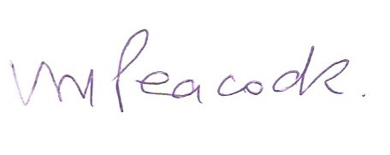

Signed: Mrs Vicki Peacock (Chair of the board of trustees).

